**Major Assignment**



**Submitted to**

Sir: Shehzad saifullah

Student Name & id

Zahid shah (12635)

Fakhar Ul Hassan (12580)

**Department of Computer Science**

**City University of Science and Information Technology Peshawar – Pakistan**

**Fit Fussion Gym Management System**

**Gym Management System:**

The gym management system is built to streamline and automate various administrative tasks involved in managing a gym or fitness center. It serves as a centralized platform that helps gym owners and staff efficiently handle day-to-day operations, enhance member experience, and optimize overall management.

**Here are some features that we have added in our gym management system application:**

**Login:**

The application provides a login interface where staff members can securely log in using their credentials, such as a username and password.

**Registration:**

New staff members can register for an account by providing their details, such as name, email, and password. The system should validate and store the registration information securely.

**Add Staff:**

Authenticated staff members with appropriate permissions can add new staff members to the system. This feature allows entering staff details like name, contact information, role, and assigned responsibilities.

**Add New Member:**

Staff members can add new members to the gym by entering their personal details, such as name, address, contact information, and membership type. The system can generate a unique member ID for identification purposes.

**Search Member:**

The application enables staff members to search for specific members by their name or member ID. This feature allows quick access to member information and facilitates efficient member management.

**Delete Member:**

Authorized staff members can delete member records from the system when necessary. This feature removes a member's data from the database, typically after membership cancellation or expiration.

**Add Equipment:**

Staff members can add new equipment to the system's inventory. This feature includes entering equipment details like name, description, quantity, and purchase date. It helps in keeping track of the gym's equipment and ensuring regular maintenance.

**Exit Options:**

The application provides an exit option or logout feature for staff members to securely log out from the system. This helps maintain data privacy and prevents unauthorized access.

**Impact of Gym Management System:**

The impact of a gym management system can be significant, benefiting gym owners, staff members, and members alike. Here are some ways a gym management system can impact a gym's operations:

**Improved Administrative Efficiency:**

A gym management system can reduce administrative workload and streamline operations by automating routine tasks like member registration, payment processing, class scheduling, and billing. This helps staff members focus on delivering quality services, enhancing overall productivity and efficiency.

**Enhanced Member Experience:**

The system can improve member experience by facilitating easy member registration, class scheduling, and payment processing. It provides a centralized platform for members to manage their memberships, receive personalized notifications, and access gym resources, enhancing member satisfaction and retention.

**Improved Equipment Maintenance and Inventory Management:**

The system helps in tracking equipment usage, scheduling maintenance, and managing inventory levels. This ensures equipment availability, reduces downtime, and extends equipment lifespan, improving gym operations and member satisfaction.

**Effective Communication and Marketing:**

A gym management system enables personalized communication with members, facilitating automated notifications, reminders, and promotional messages. This enhances member engagement, increases referral rates, and supports effective marketing strategies.

**System requirements:**

To develop a gym management system in C#, you'll need to consider the system requirements for the application development environment as well as any specific requirements for the gym management system itself.

**Operating System:**

Windows 7 or higher.

**Computer:**

A desktop computer or laptop with a modern processor (e.g., Intel Core i5 or equivalent) and sufficient RAM (at least 4GB or higher).

**Storage:**

Adequate storage space to accommodate the gym management software and database. SSD storage is recommended for better performance.

**Integrated Development Environment (IDE):**

Microsoft Visual Studio, preferably the latest version available at the time.

**Login:**

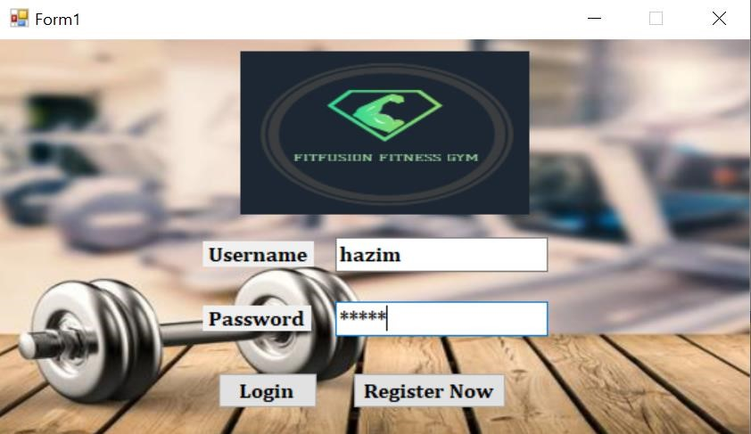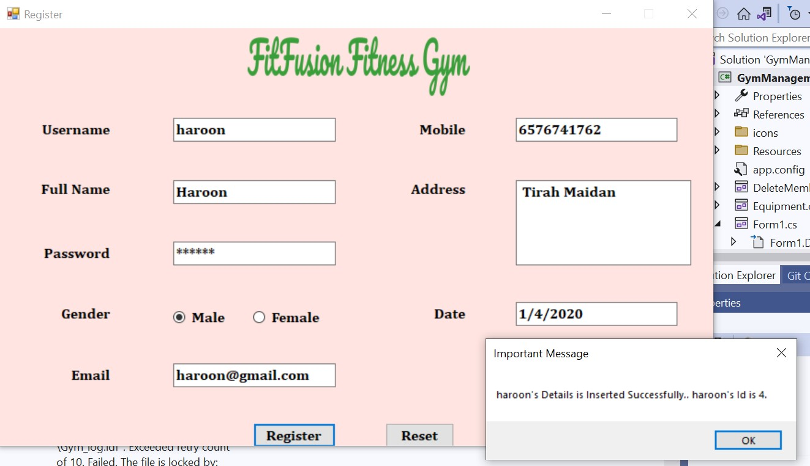

Here we login or registered and then login to the Gym application to access and manipulate the data present in it.

**Database View:**

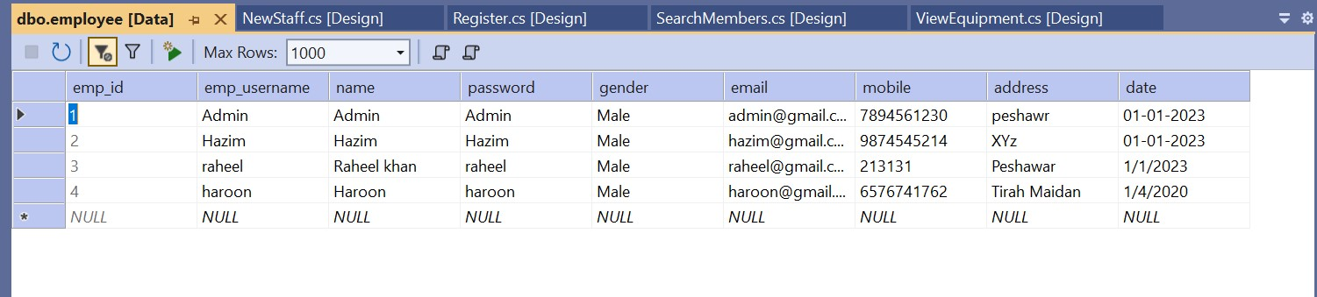

This is the Database Table for Employ which include the **(emp_id,emp_username,name,password,gender,email,Mobile,addre ss, date)** attributes in which data is stored in Data Base.

**Home:**

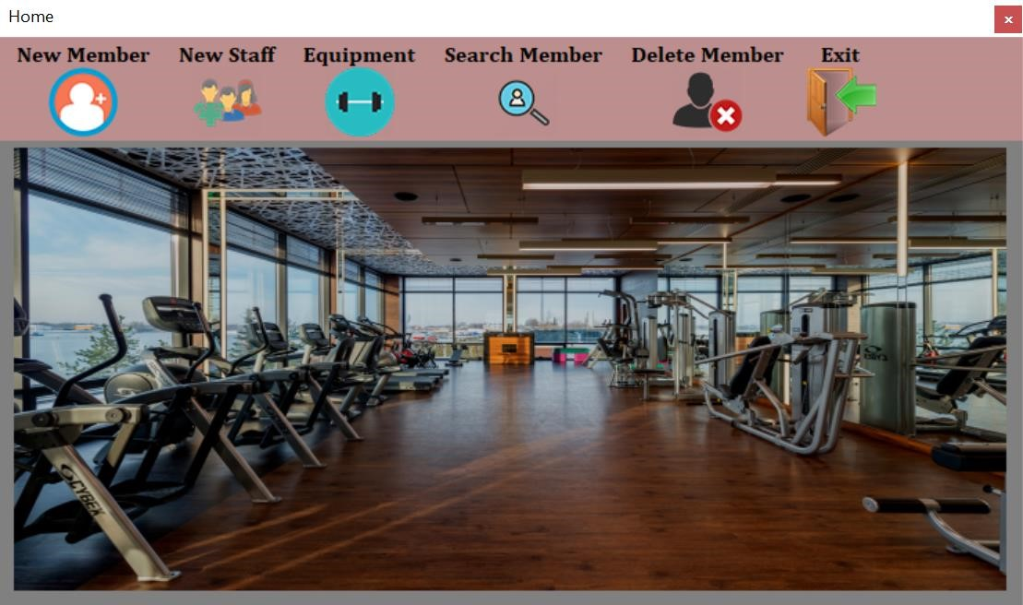

After login to application home window appear in which we can choose the option and perform our work.

**New Member:**

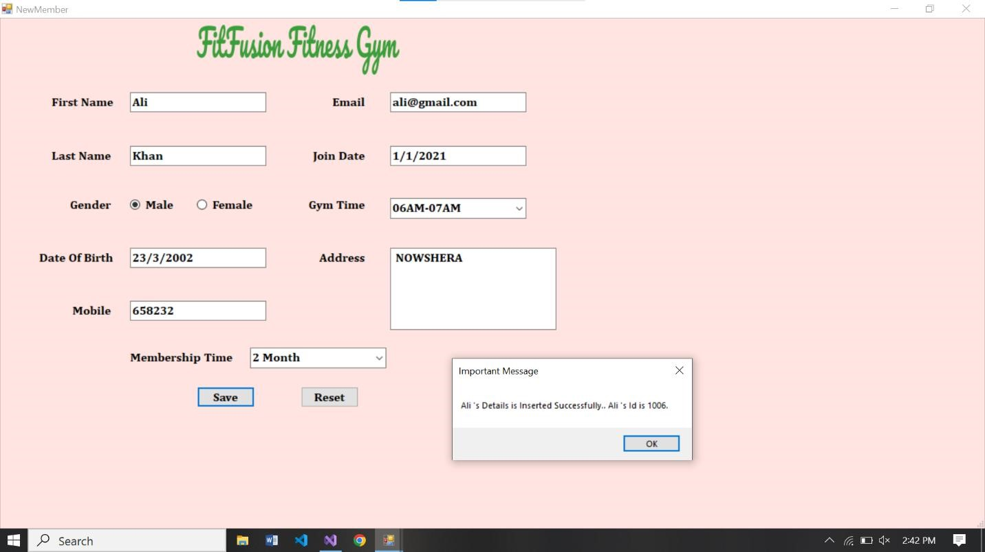

On Clicking the New Member option this window appear in which we can add new members of the gym by inserting their details.

**Database View:**

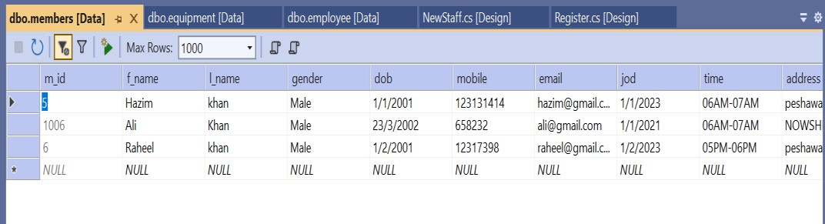

This is the data base for Gym members which include the **(m_id,F_name,l_name,gender,DOB,Mobile,Email,joining_date,timi ng,address,membership)** attributes in which data is stored in Data Base.

**New Staff:**

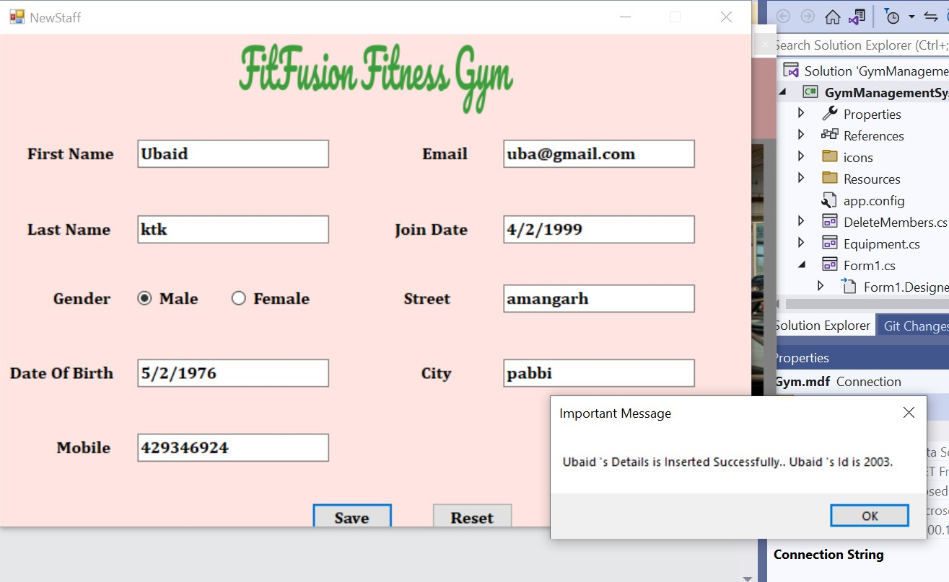

On Clicking the New Staff option this window appear in which we can add New Staff of the gym by inserting their details.

**Database View:**

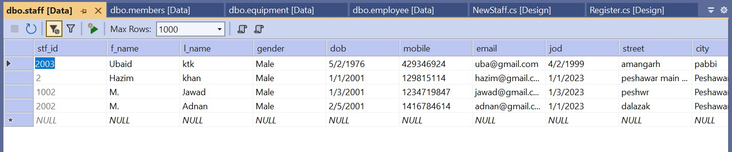

This is the Database table for Staff members which include the **(stf_id,F_name,l_name,gender,dob,mobile,email,joining_date,Streat, city)** attributes in which data is stored in Data Base.

**Equipment’s:**

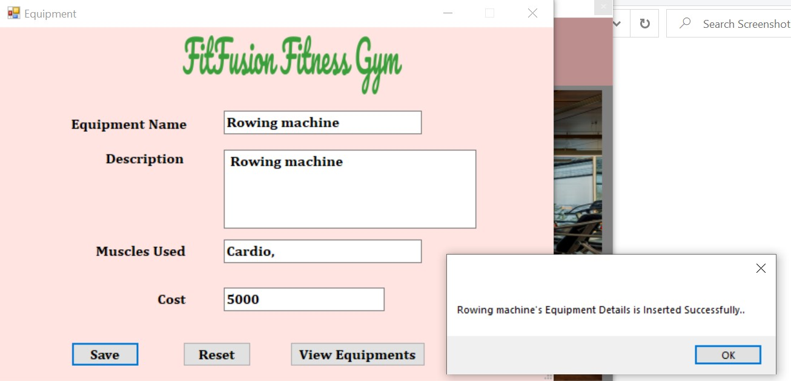

On Clicking the Equipment’s option this window appear in which we can equipment’s of the gym by inserting their details.



This Table shows the equipment’s and its details which are inserted by the Admin.

**Database View:**

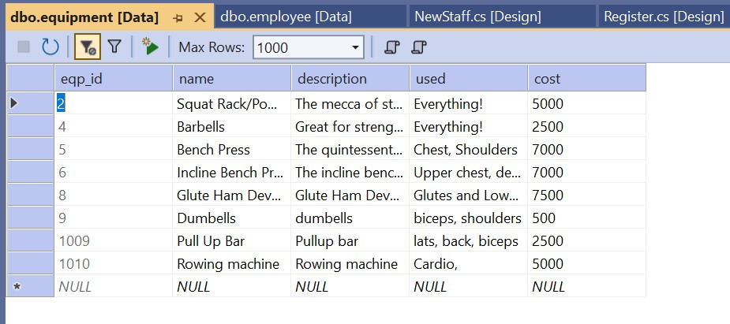

This is the Database table for Equipment’s which include the **(eqp_id, name,description,used,cost)** attributes in which data is stored in Data Base.

**Search Member:**

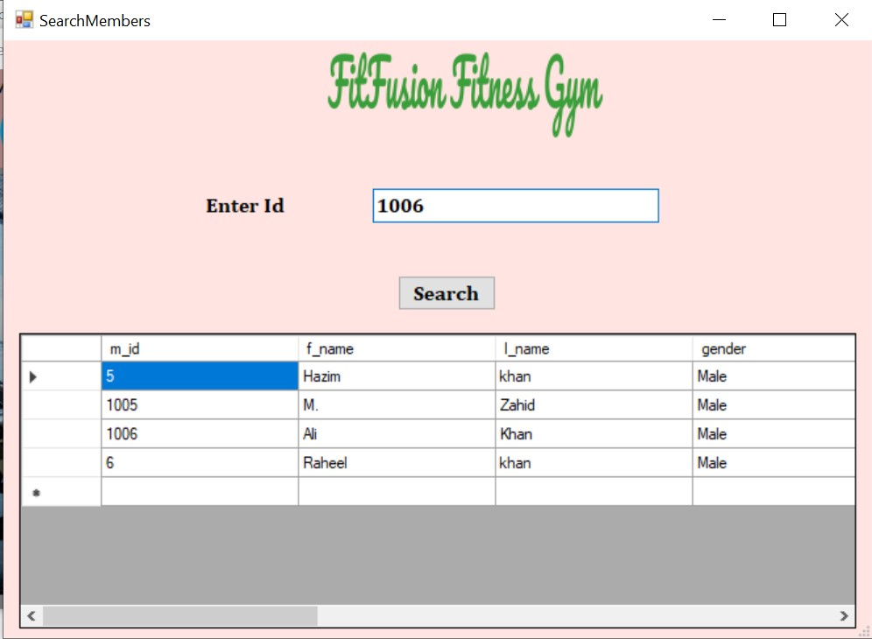

On Clicking the Search Member option this window appear in which we can search gym member by inserting their Member_ID.

**Member Searched by ID(1006):**

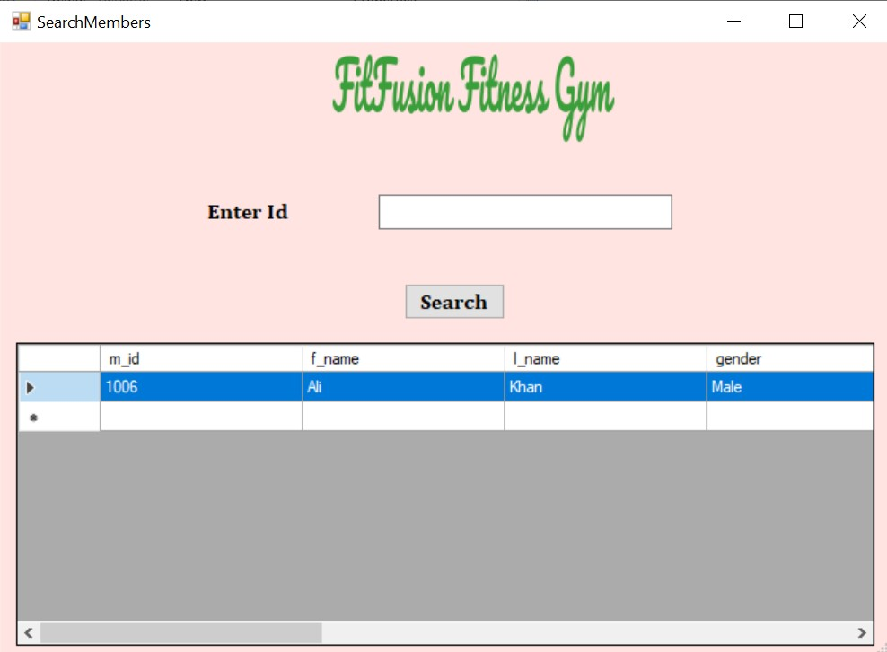

Here is the Member with ID 1006 which is searched from the table and this is updated table view.

**Delete Member:**

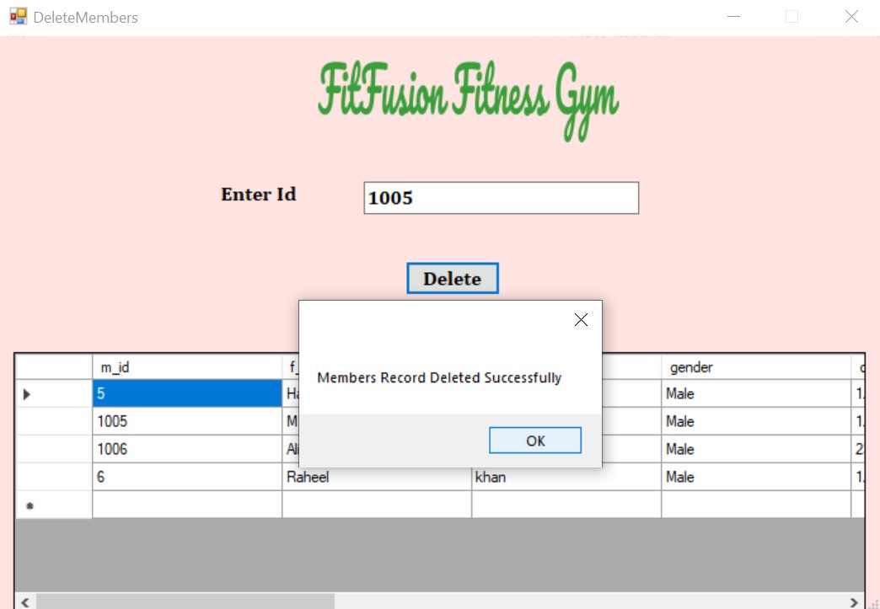

Here we select the Member by his ID Number and then press Delete Option So the Member delete From the Table.

**After Deletion:**

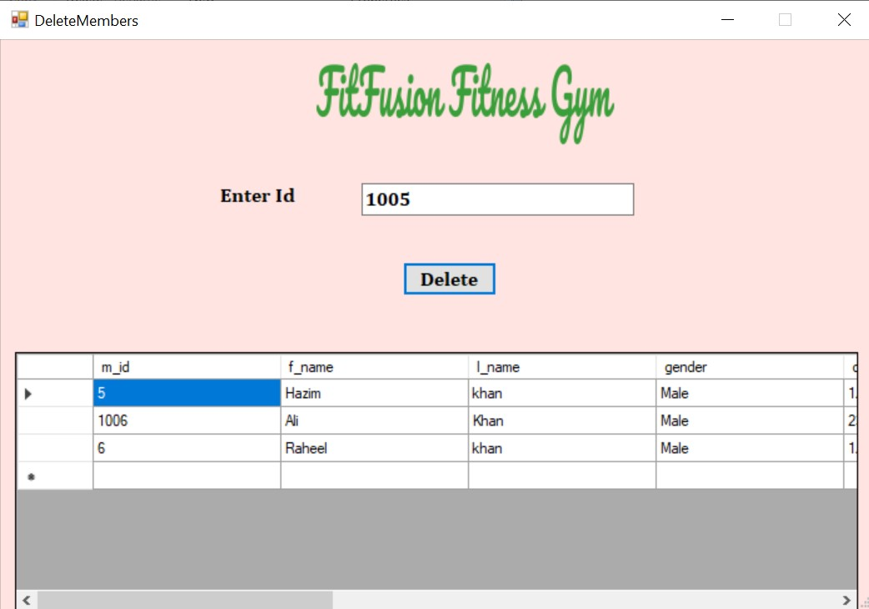

Here the Member with ID 1005 is deleted from the table and the table is updated.

**Exit Option:**

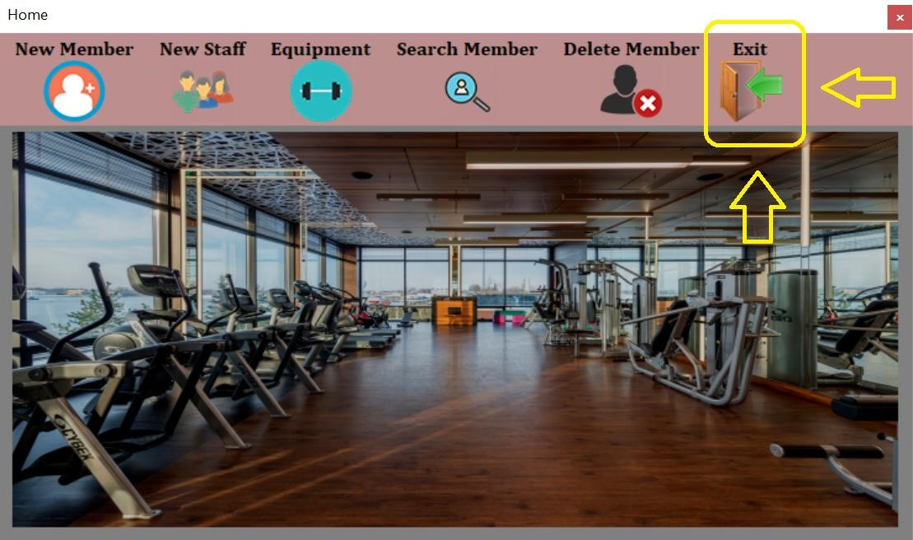

After pressing exit button you will exit from the Application.